Based on your Group, you will perform cleansing, take the full page screenshot of every step (system Date and time must be visible), and write the steps you performed. Once the data is cleaned, you can create a story which explains the data.

Each member of the group must perform the work and share the cloud link where the files are stored. Also, mention the submission which you like to get marked.

Files needed to submit by each member:

1. TBWX file
2. Word/PDF file containing all the screenshots and explanation.

Good Luck!

Combined 2

|  |  |  |  |
| --- | --- | --- | --- |
| MemberName | Student ID | URL | To be marked |
| Donny Gulley |  |  |  |
| Arora, Pranit Mukesh |  |  |  |

Removed Special Characters

Query 7 Cleaned â€œ and â€

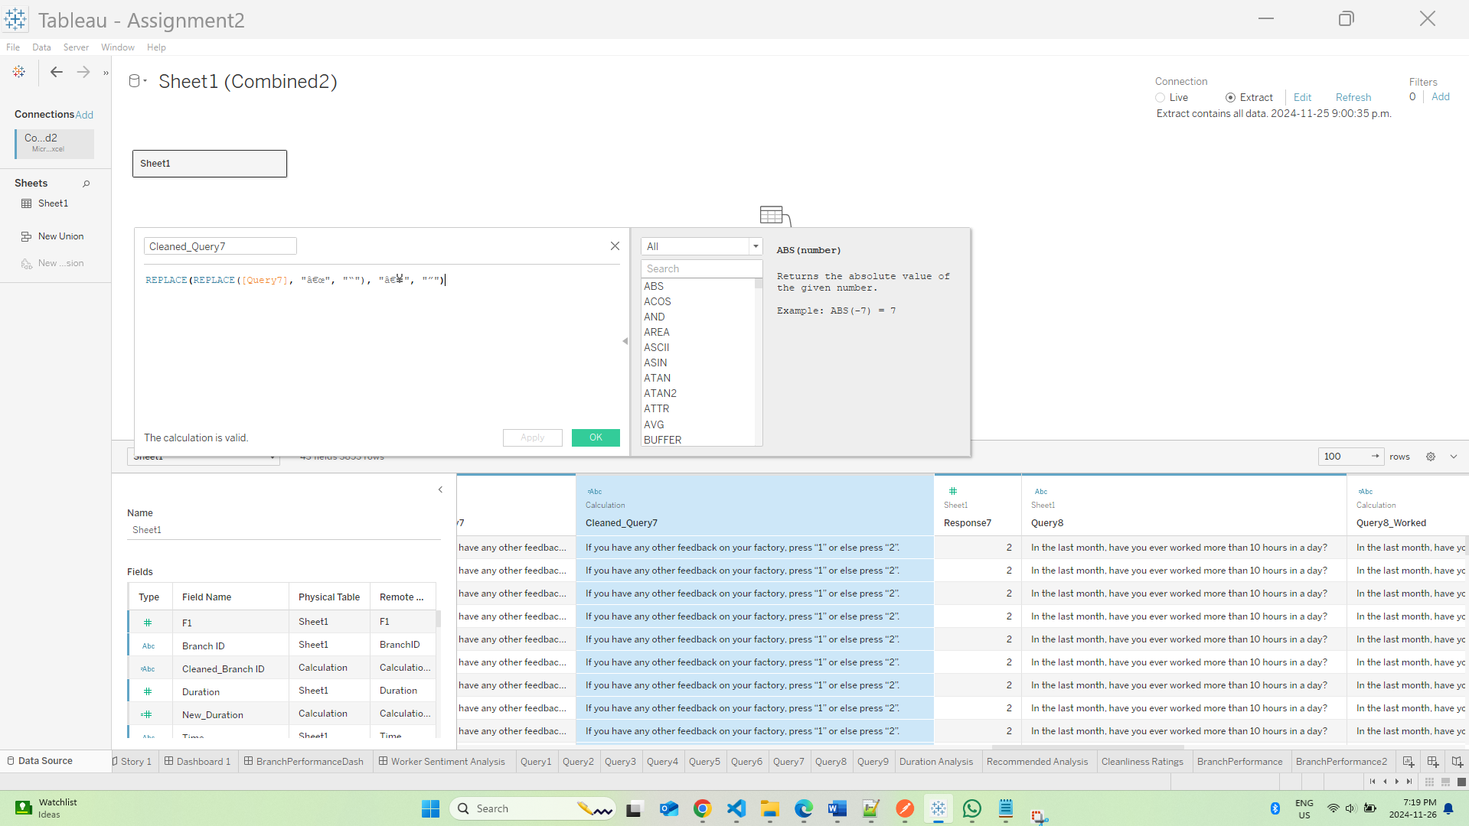

Standardized “Time” with a function and set to a datetime as type

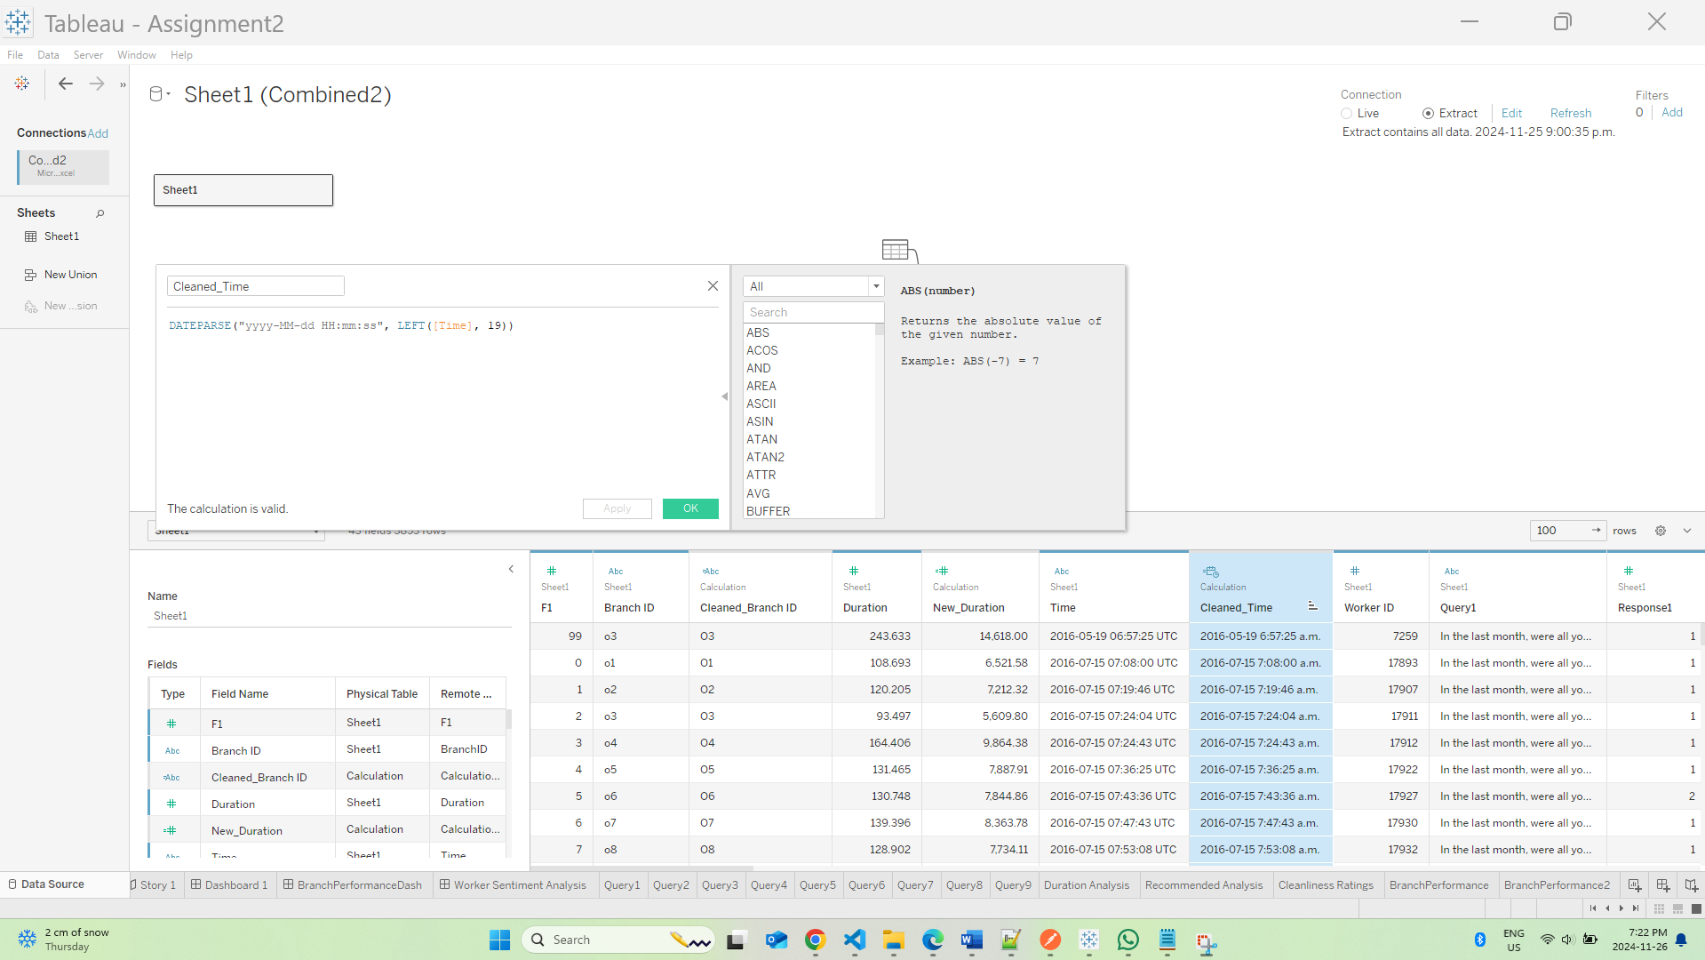

Create a Duration in Second Calculated field

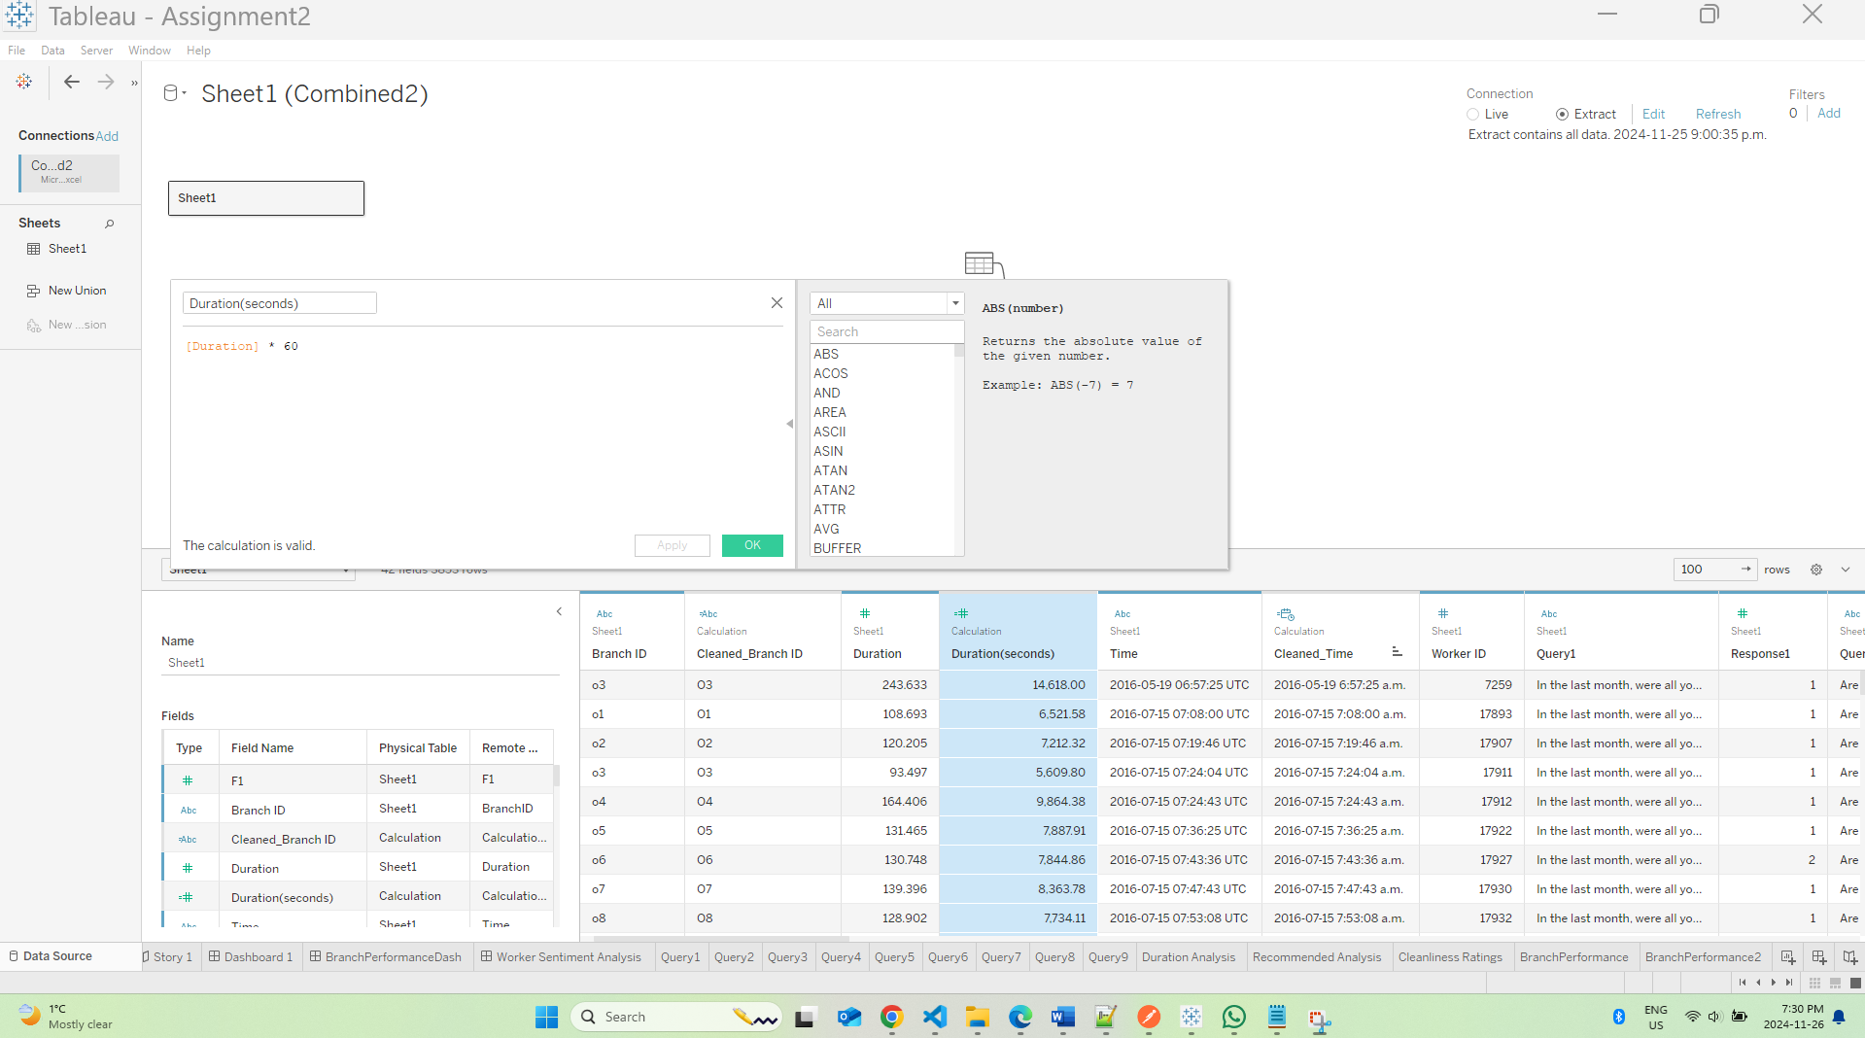

Standardize text data in columns like BranchID by creating a new calculated field number named cleaned_branchid

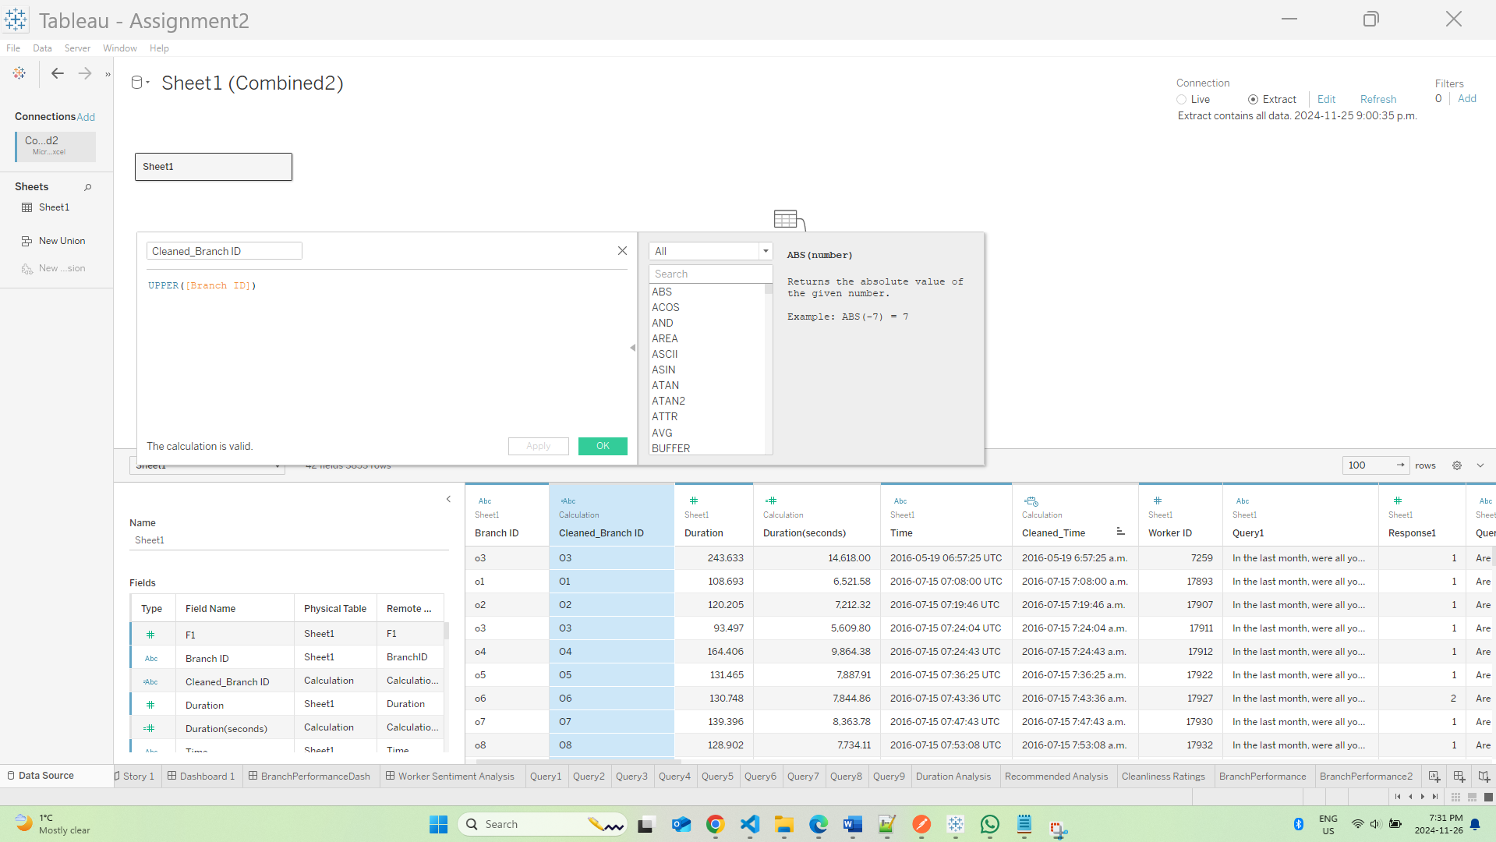

Broke out question in Query 8 into 2 types worked more than 10 hours vs union trade workers

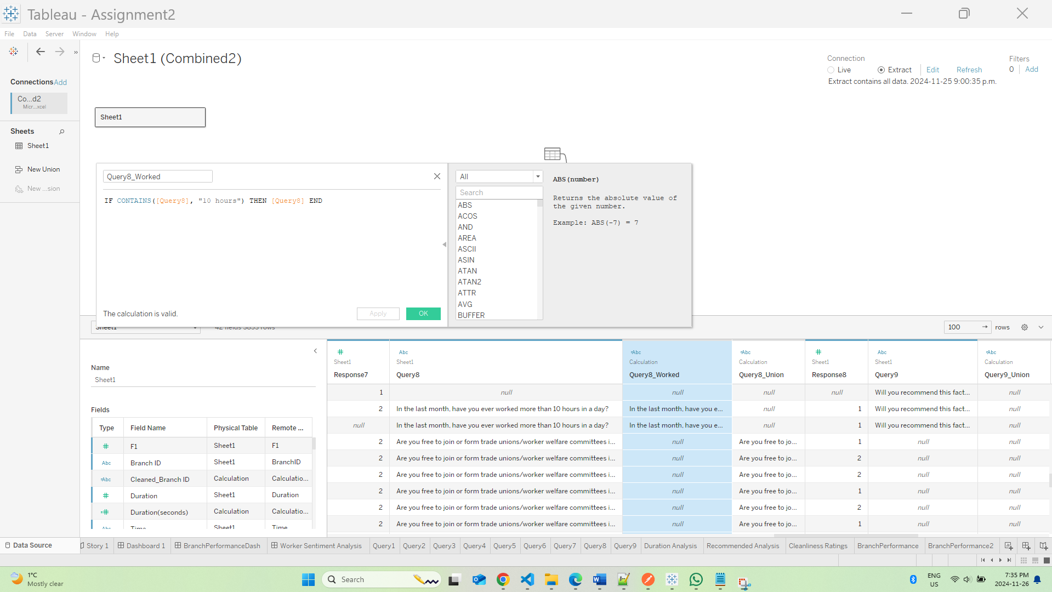

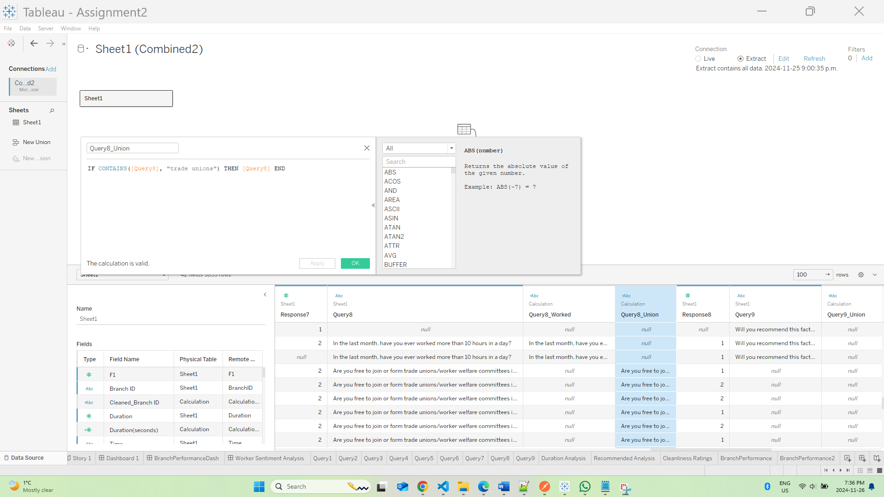

Broke out Query 9 for Union related and recommendation questions

